**EXCELLENT COACHING**

|  |  |  |
| --- | --- | --- |
| **Supervisor.** | **Sir-Irtiza** | |
| **Batch.** | **2306E1** | |
| **Group.** | **-** | |
| **Serial No.** | **Enrollment Number** | **Student Name** |
| **1.** | **Student1477355** | **Zohra Ghullam Muhammad** |
| **2.** | **Student1478317** | **Aqsa Jamil** |
| **3.** | **Student1474339** | **Nayab Ahmed** |
| **4.** | **Student14324** | **Fayez Qamar** |

**ACKNOWLEDGEMENT**

The first, we would like to express my special thanks of gratitude to my teacher **Sir-Irtiza** who help us alto in finalizing this project within the time frame, valuable counselling and assistance for the accomplishment of this project.

Secondly, we would also like to thank the e-Project team at Aptech Head Office, who gave us the golden opportunity to do this wonderful project about Excellent Coaching.

Thirdly, we also thank the e-Project team, some of the benefits are as under:

* Re-enforcement of skills happens in the experiential learning process.
* A mentor, ensuring that we do not get drifted, constantly guides us.
* It gives us a lot of confidence to face an interview as we have worked on a project. We can explain virtually everything on the subject we have learnt.

**SYNOPSIS**

*As more and more people join the internet, furthermore looking at the growing demand of the coaching centers, a website was designed to display the courses available on the internet.*

*The following website is designed using many preferences and designs targeting young youth.*

*Below, you would find the introductions, courses and faculty of excellent coaching that you find interesting.*

*Excellent coaching shares the best courses and every single detail on its website, you can find the infrastructure and pictures of the coaching on our website with the courses that we offer and their fee structure.*

**PROBLEM DEFINITION**

Excellent Coaching is into business for more than a decade. They have been advertising about their coaching classes through newspapers, pamphlets, television. Now with changing times, they have decided to go online as most of the students today are frequent users of Internet. They have planned for a website with complete details about the Coaching classes.

So. We solved many particular queries as followed:

* How the sitemap possibly looks alike?
* What information should be displayed on each page?
* How to put every comment is friendly?
* How to give users the best experience when using the website?
* How to let the website properly functioning along with the system requirements?
* Will the user ne able to contact with Excellent Coaching for advice?

**CUSTOMER REQUIREMENT SPECIFICATION (CRS)**

After discussion, we are supposed to create a website for them with the below mentioned requirements specifications:

* The Home Page should have suitable logo, and decent color combination.

Information should be neatly placed at suitable location.

* Various pages having information about different courses/subjects taught at

the classes, Faculty/Teachers complete information and previous year’s

success stories should be listed.

* The site should display a menu which will contain the options for brief

introduction about the above-mentioned information, location/address of the

coaching classes and any other information if required.

* The information should be categorized according to different subjects like if a

User wants to see details of ‘Commerce’ then he clicks on a Link/button/menu

etc. and he will see details of course structure of commerce. Similarly, for

‘Mathematic’, ‘Languages’ and other subjects.

* When a user selects any course stream, complete list of subjects for that

course stream will be displayed.

* Details of the courses should be displayed on the Web Page along with the

title and it should be stored in Individual Word documents which can be

downloaded or viewed by the User who wishes to see the same.

* Price List for all courses should be available for download.
* There should be a “Contact Us” page which will have the Address of the

Coaching Classes and the mail address which when clicked will invoke the

local mail client from where they can send an email.

**SCOPE OF THE WORK (IN BRIEF)**

The website is to be developed for the Windows Platform using HTML5, JavaScript and Geolocation. The site should work well in all leading browsers including Chrome, IE, Firefox etc.

Home Page show Top best courses/subjects, testimonials, faculty….

Every content direct to relative content.

1*.Index.html (index.html)*

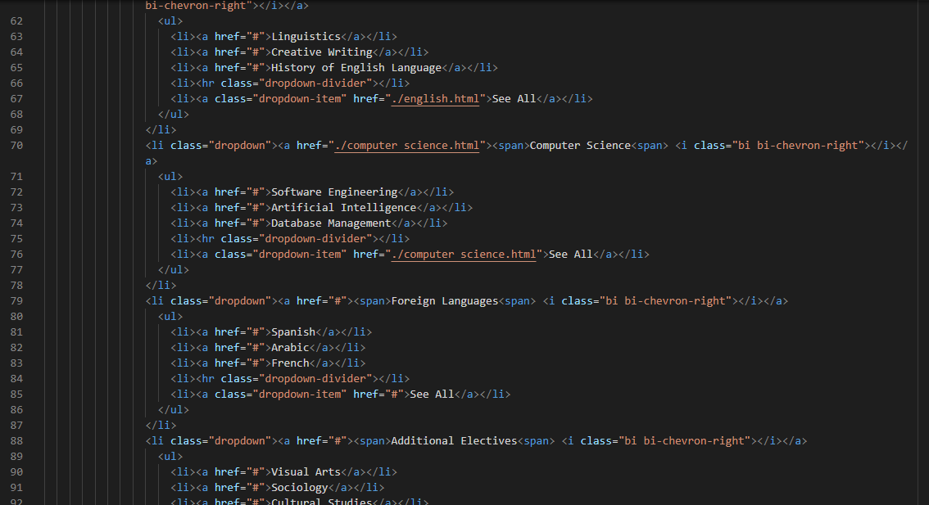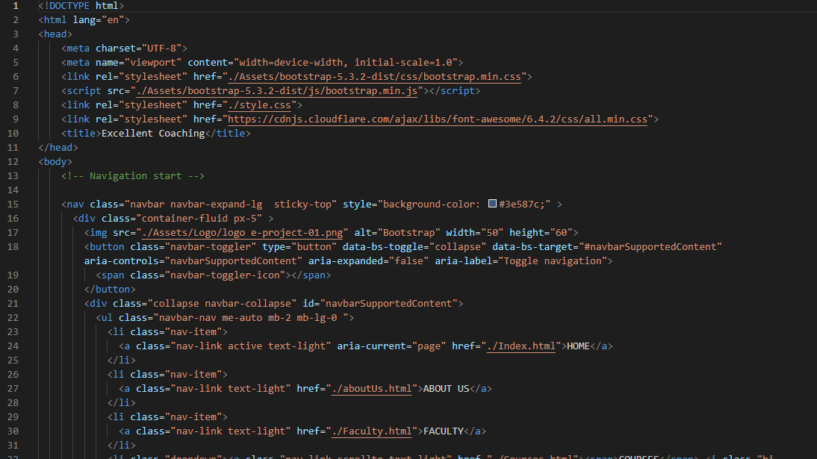

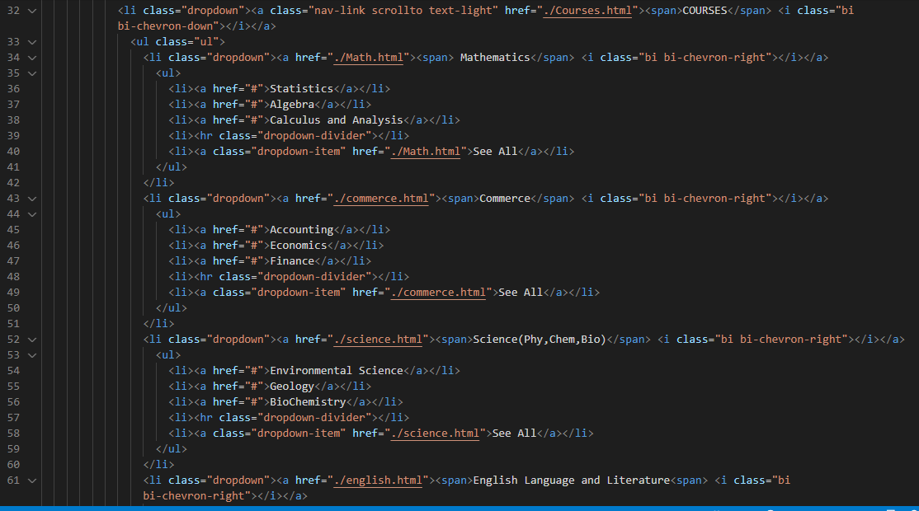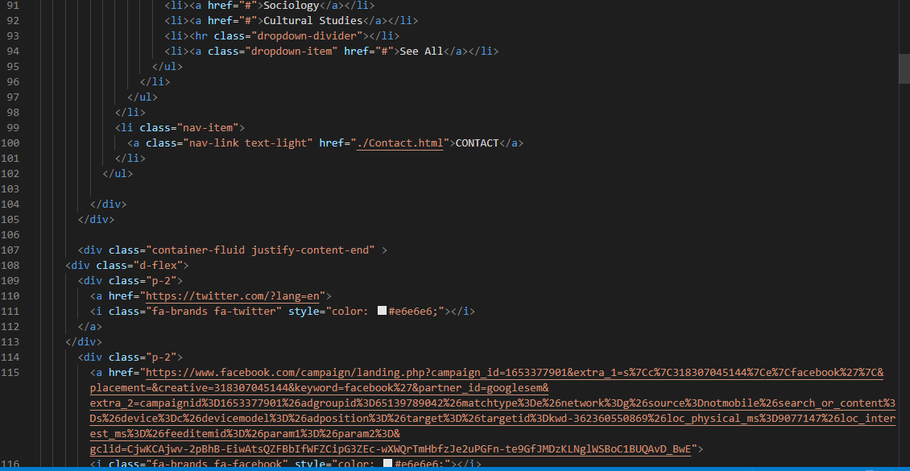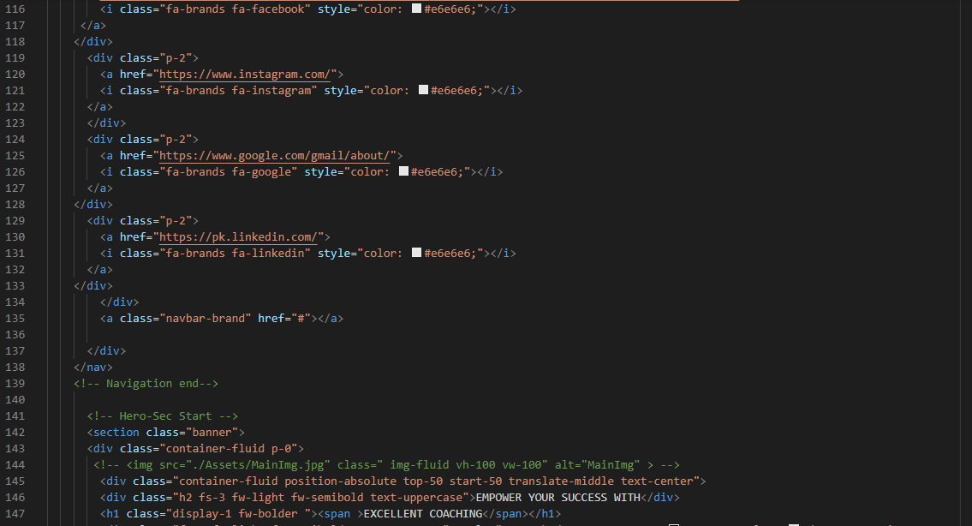

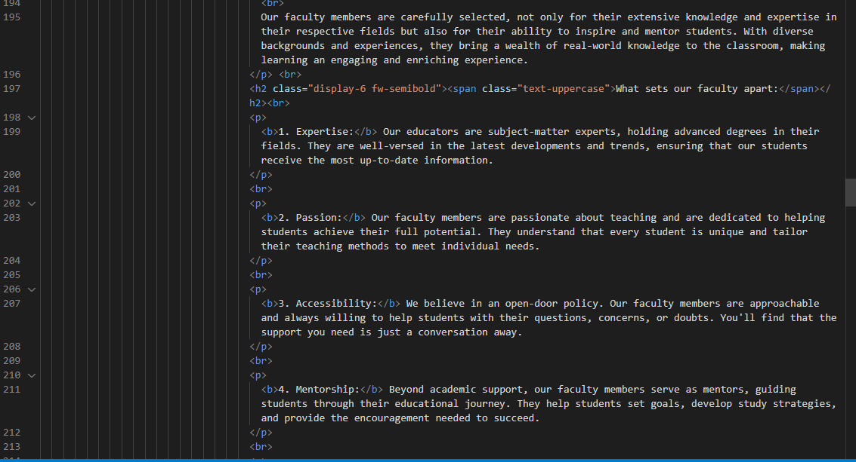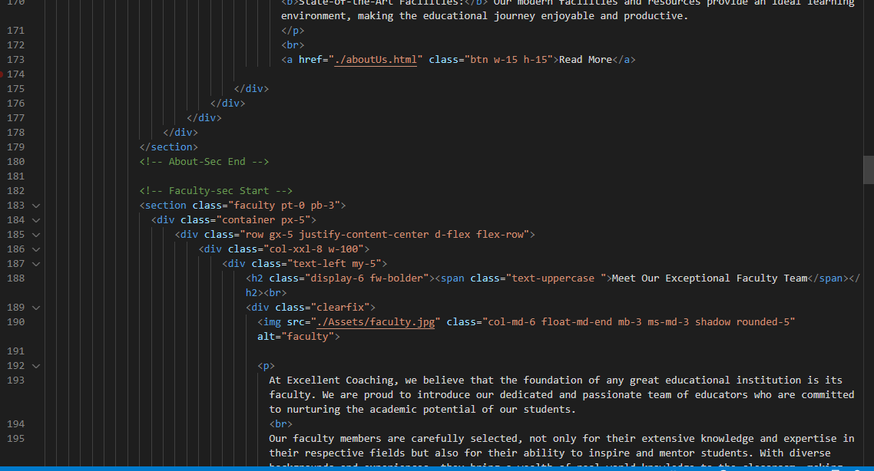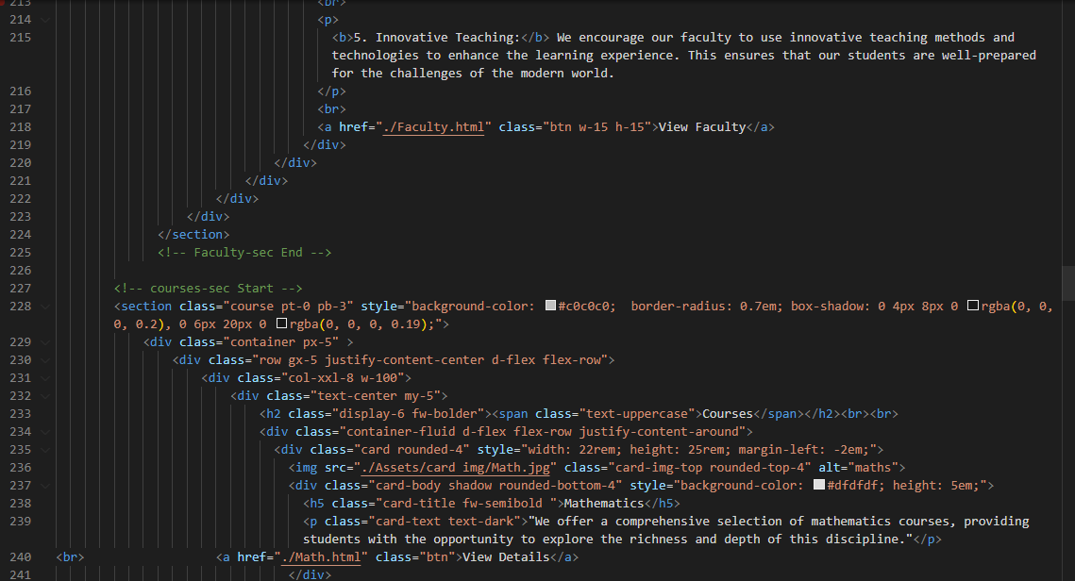

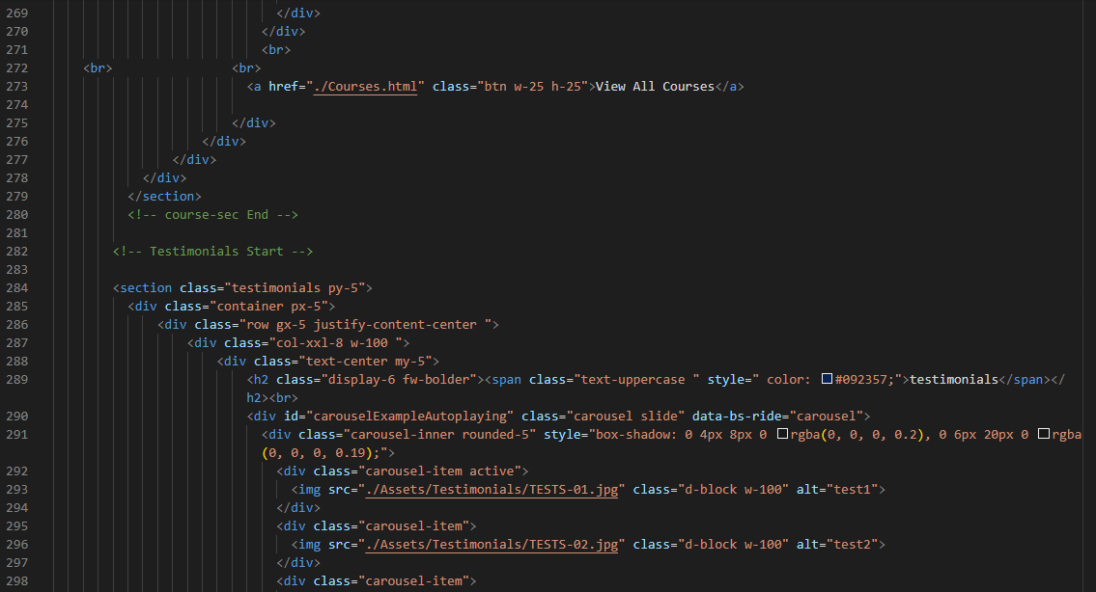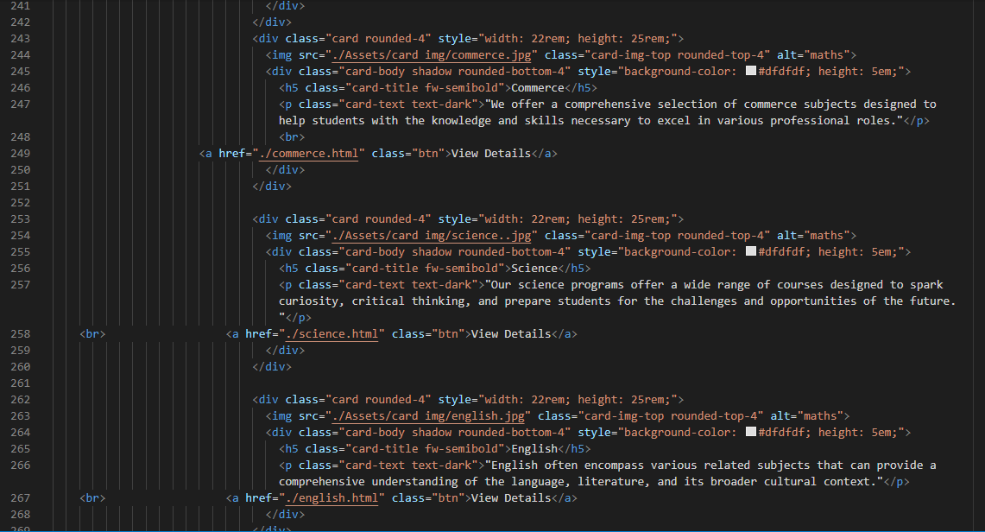

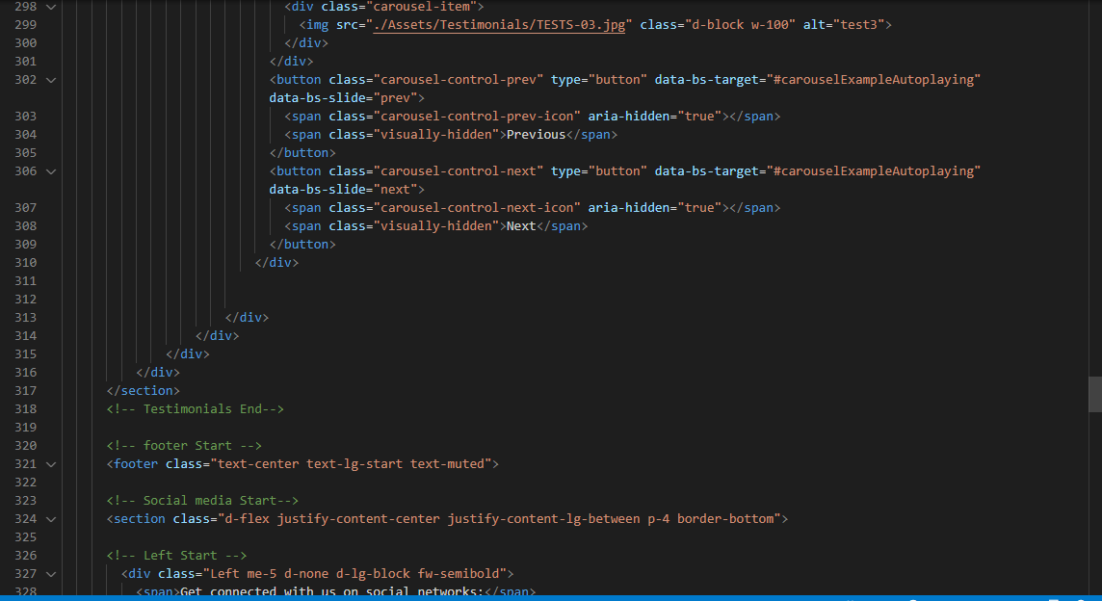

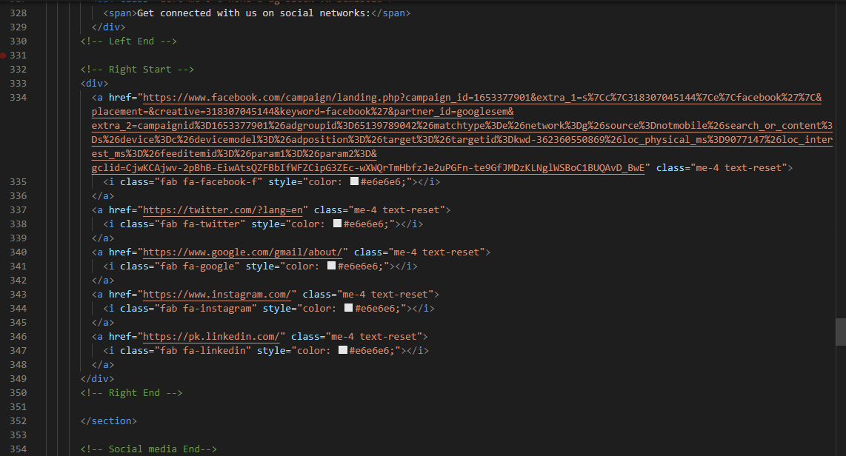

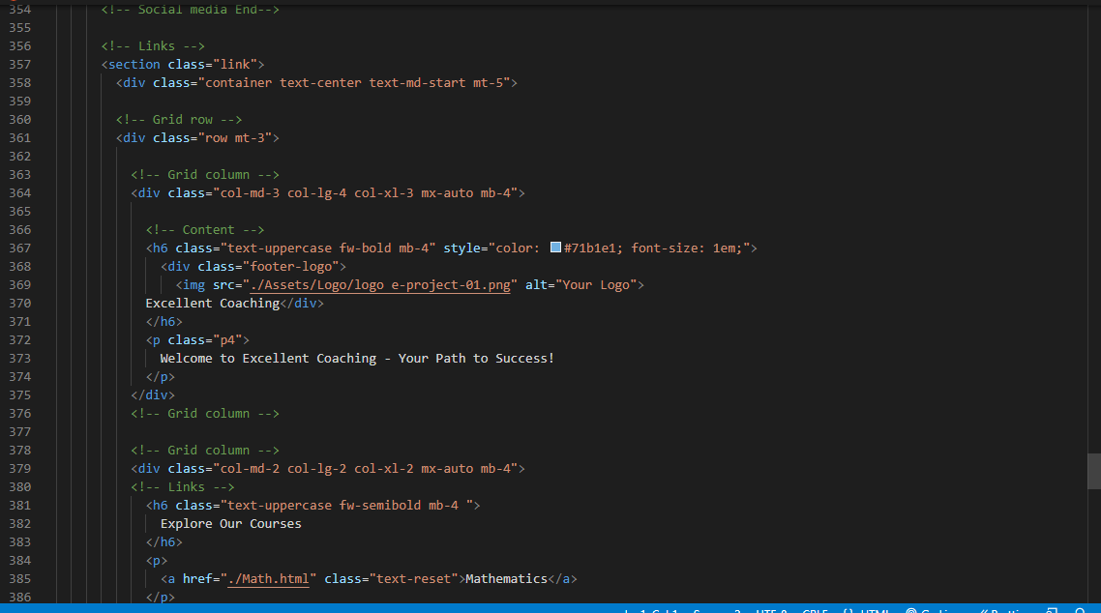

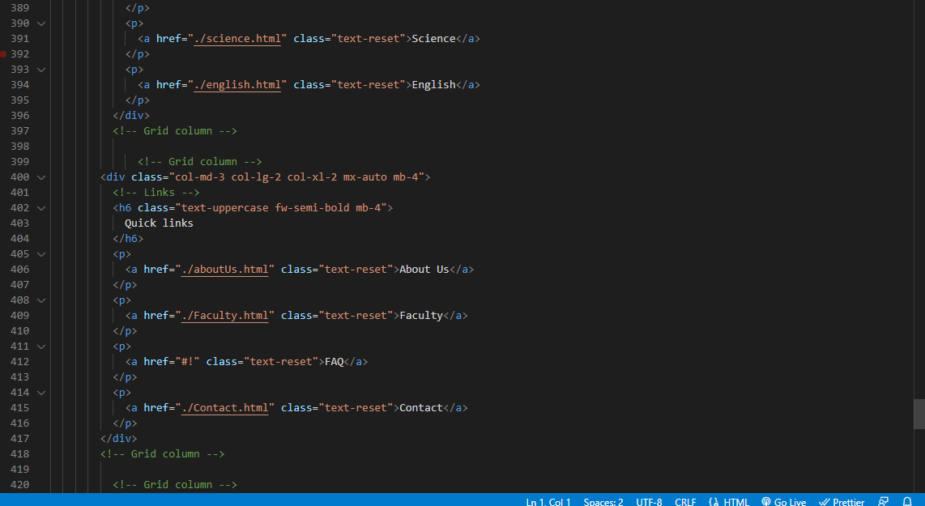

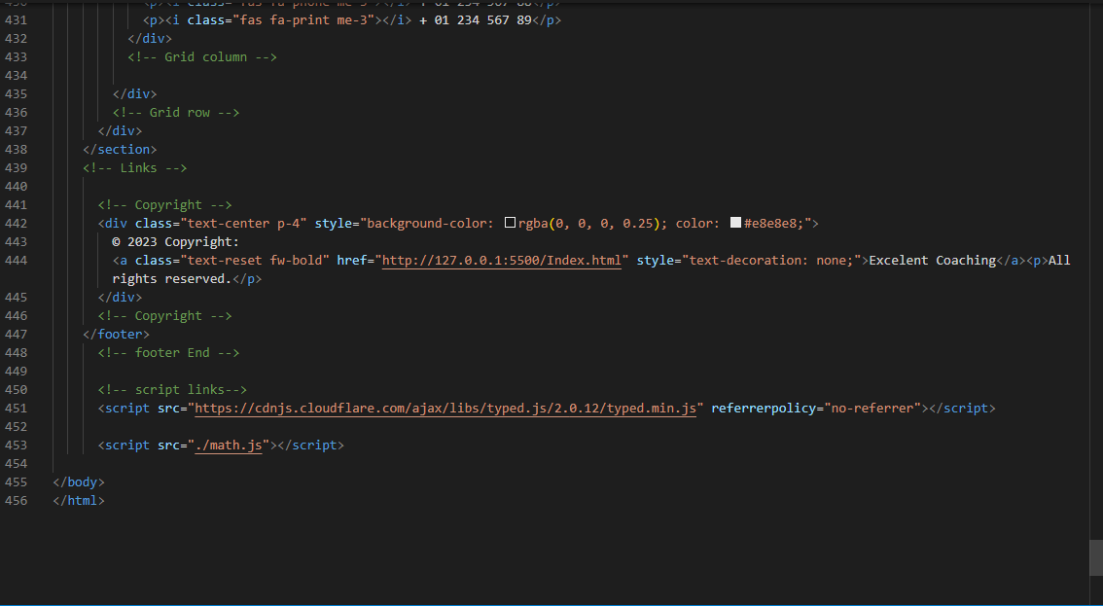

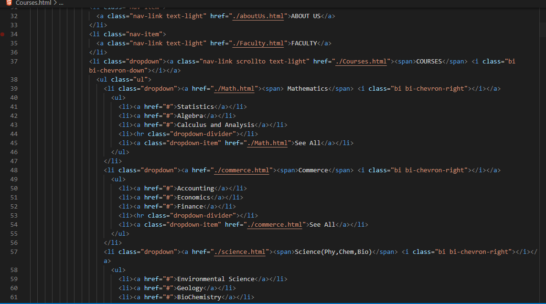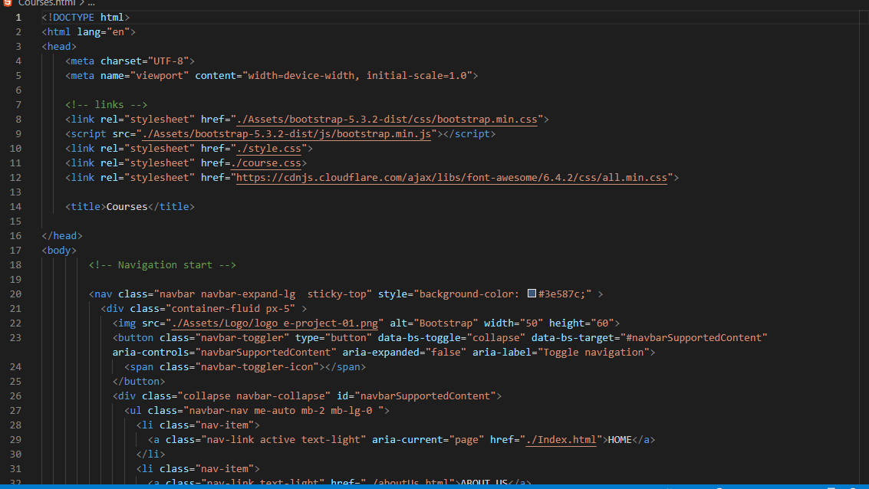*4.Courses Page (courses.html)*

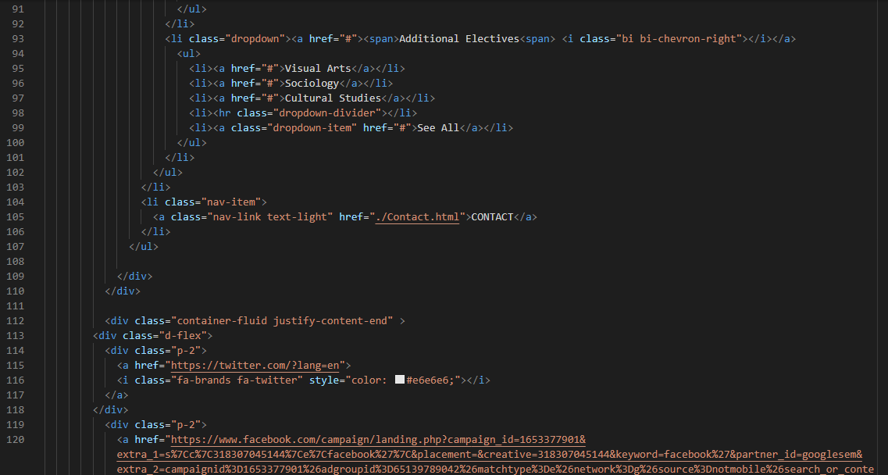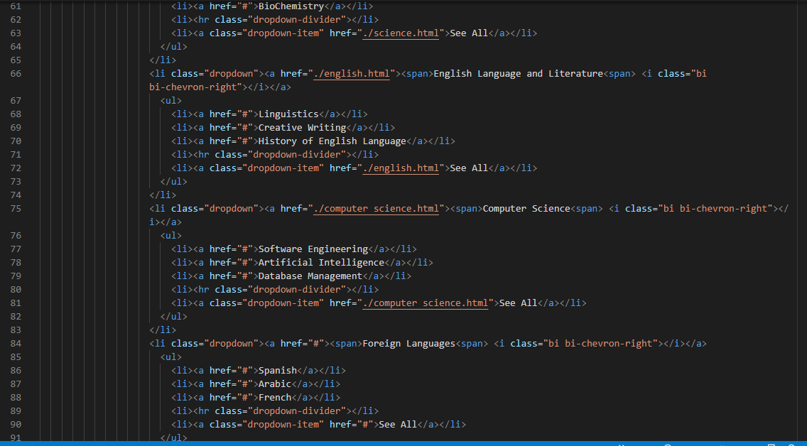

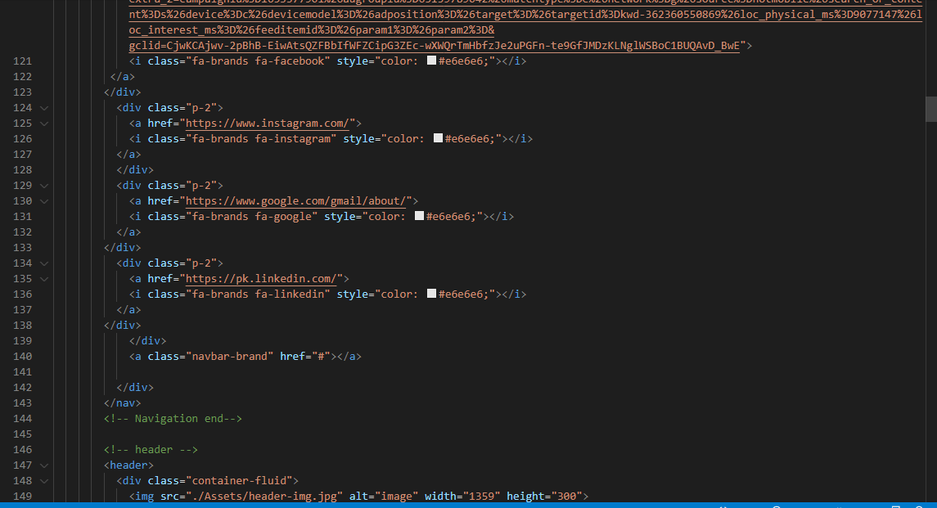

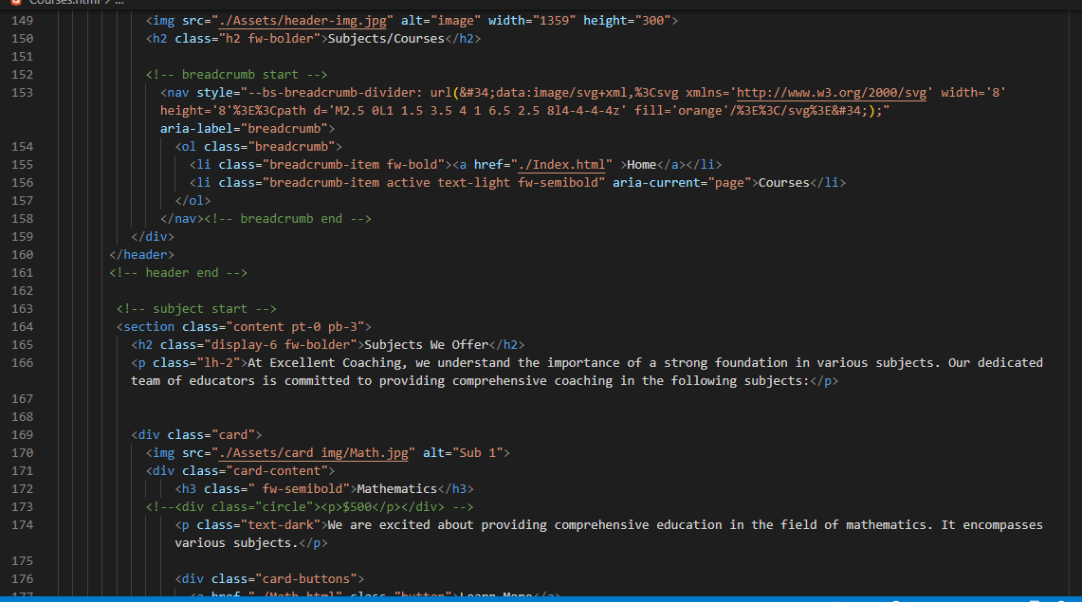

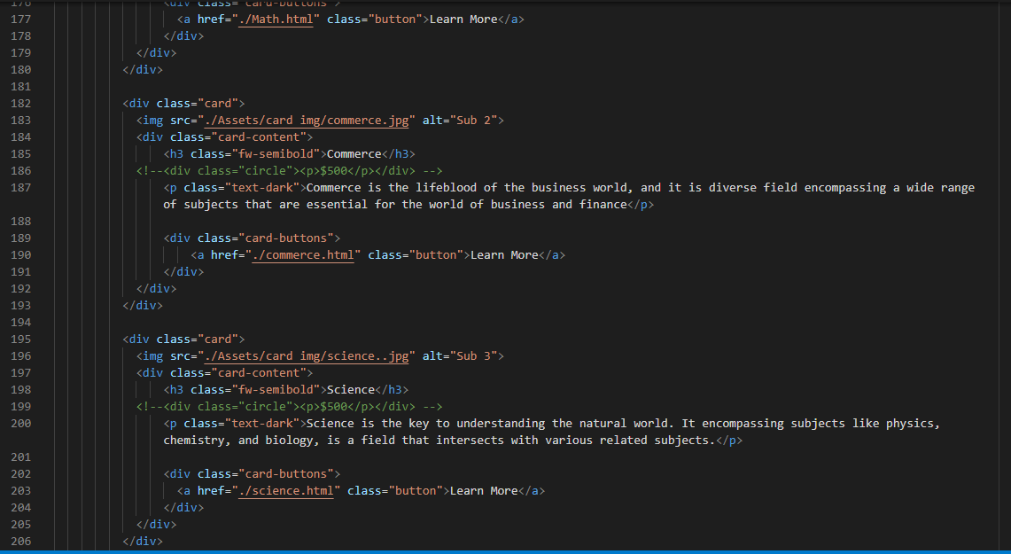

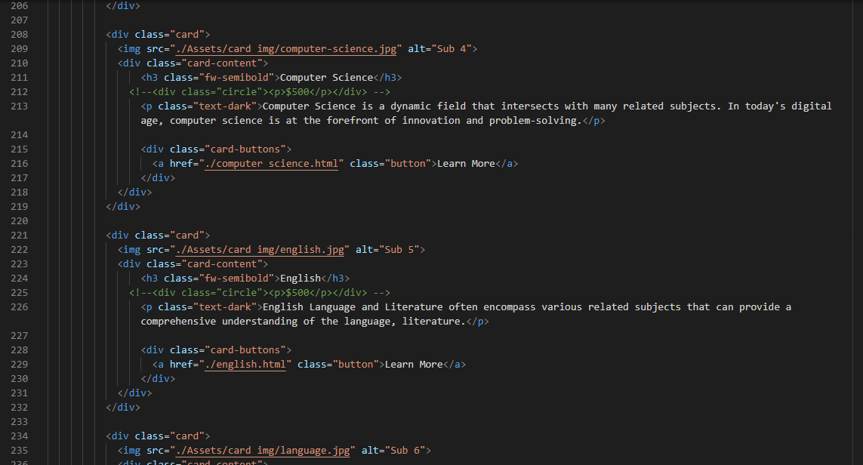

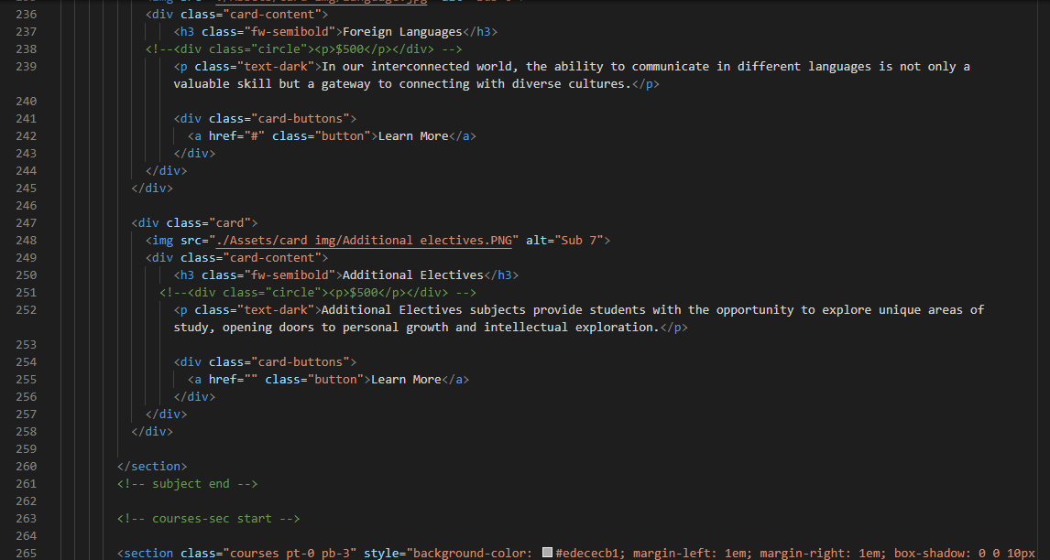

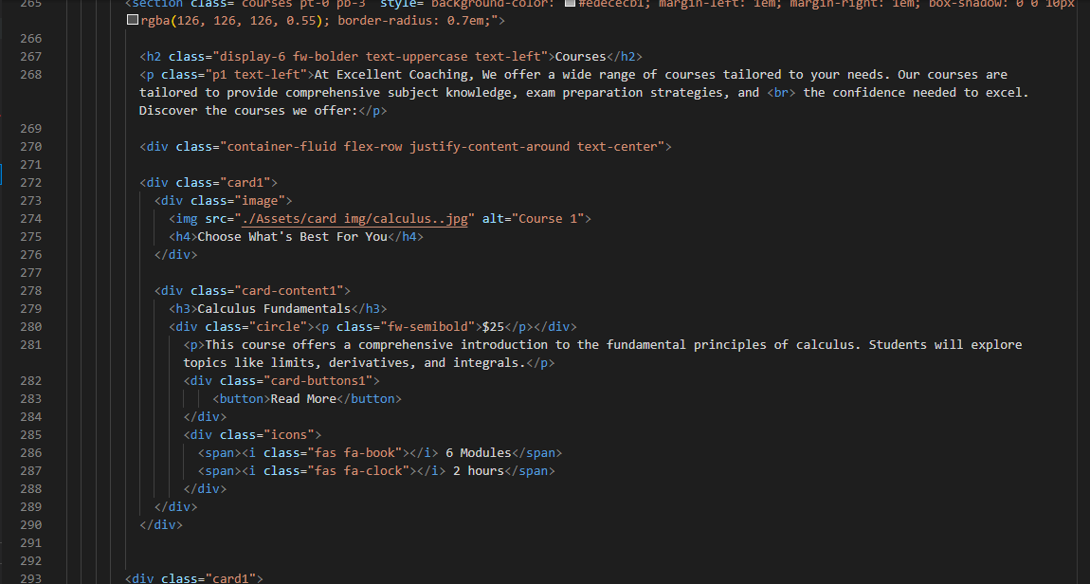

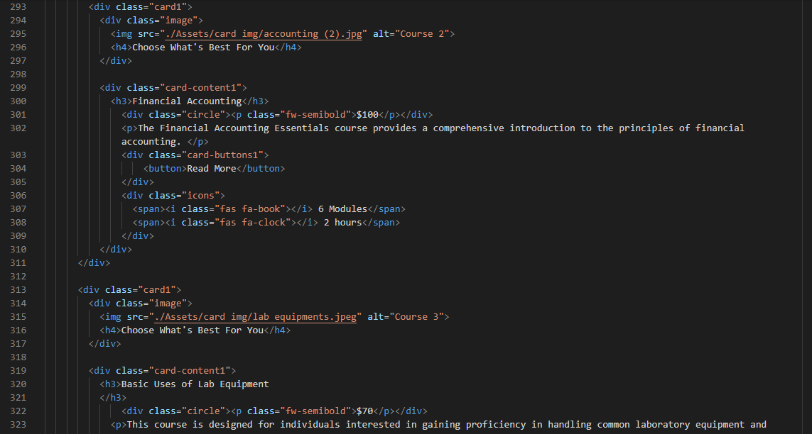

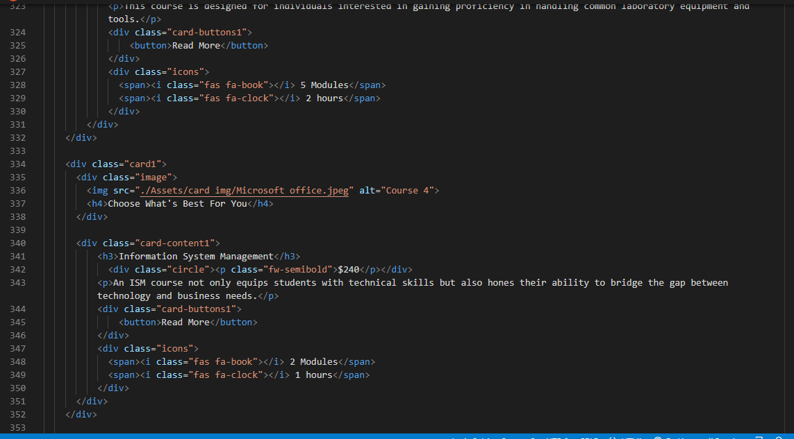

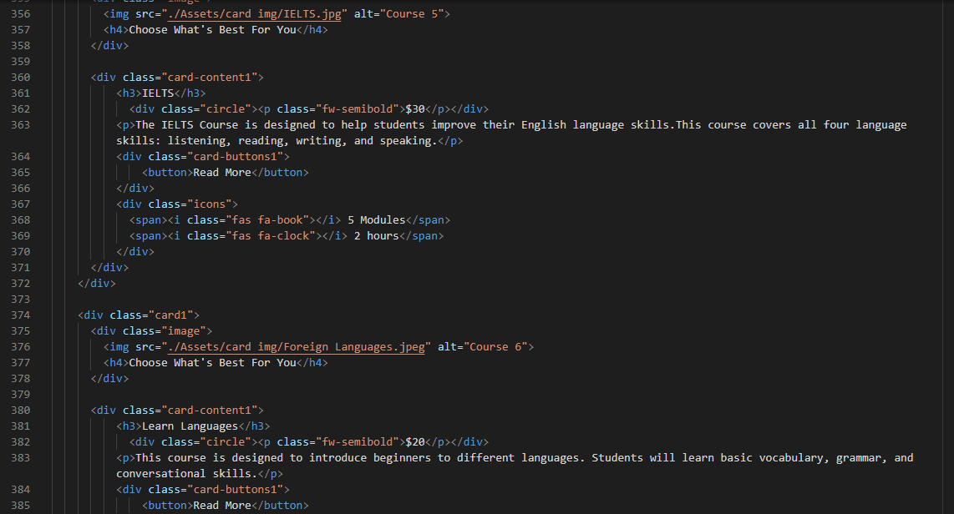

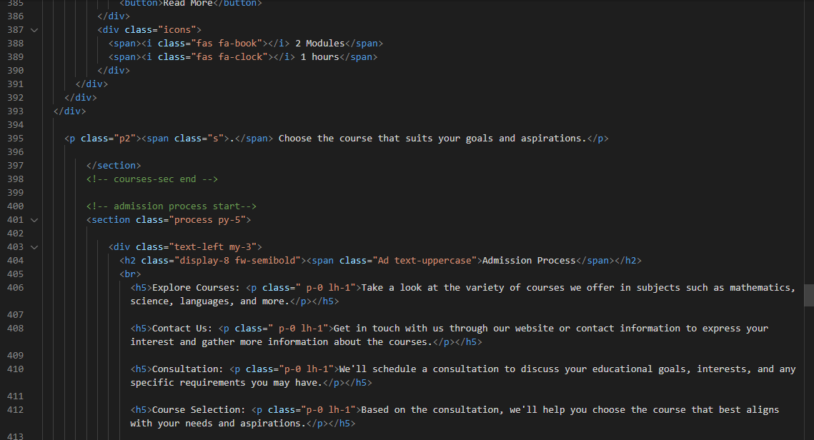

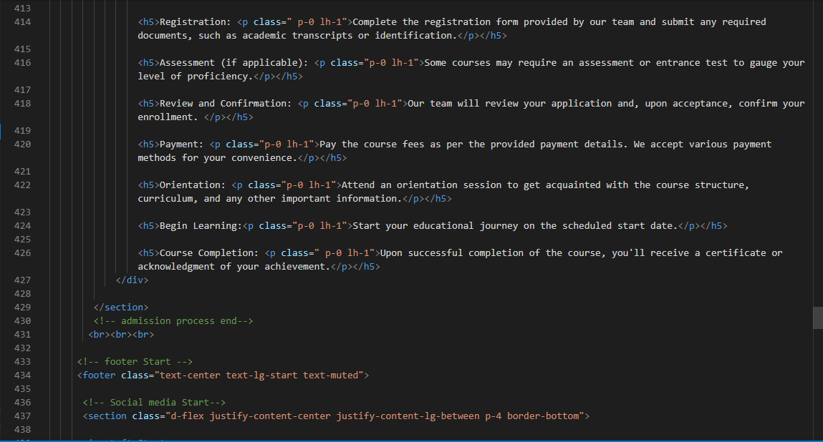

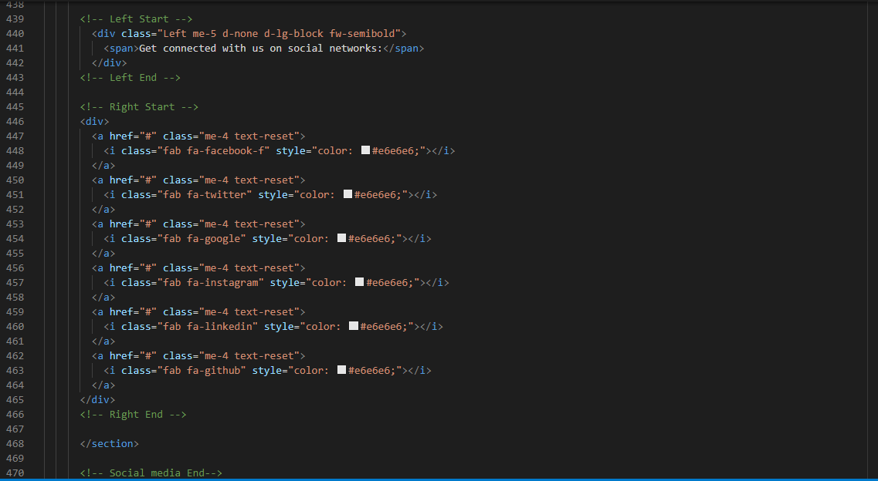

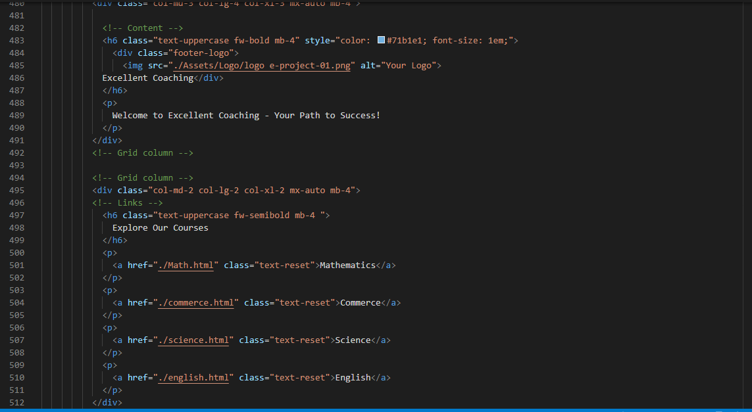

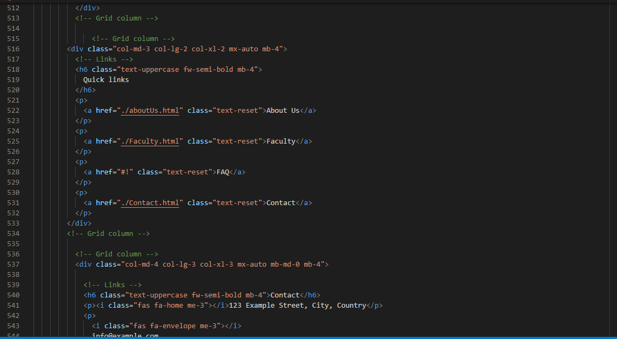

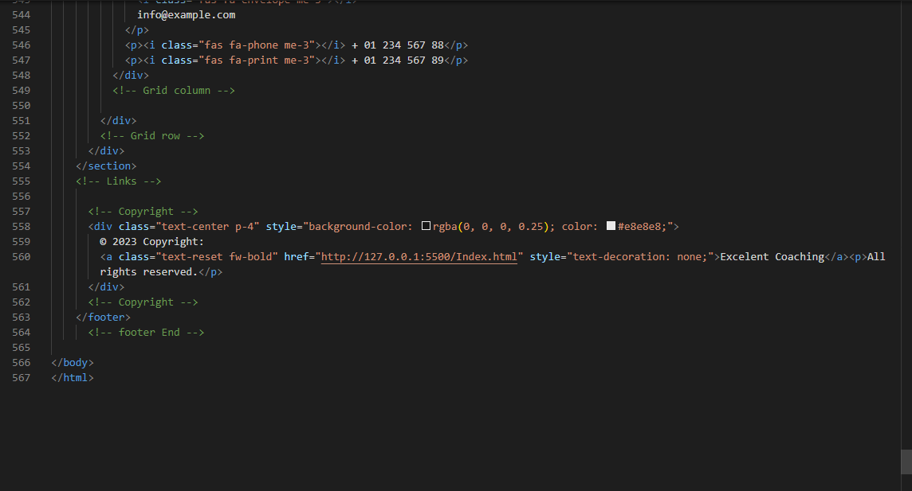

5.Contact Page (*contact.html*)

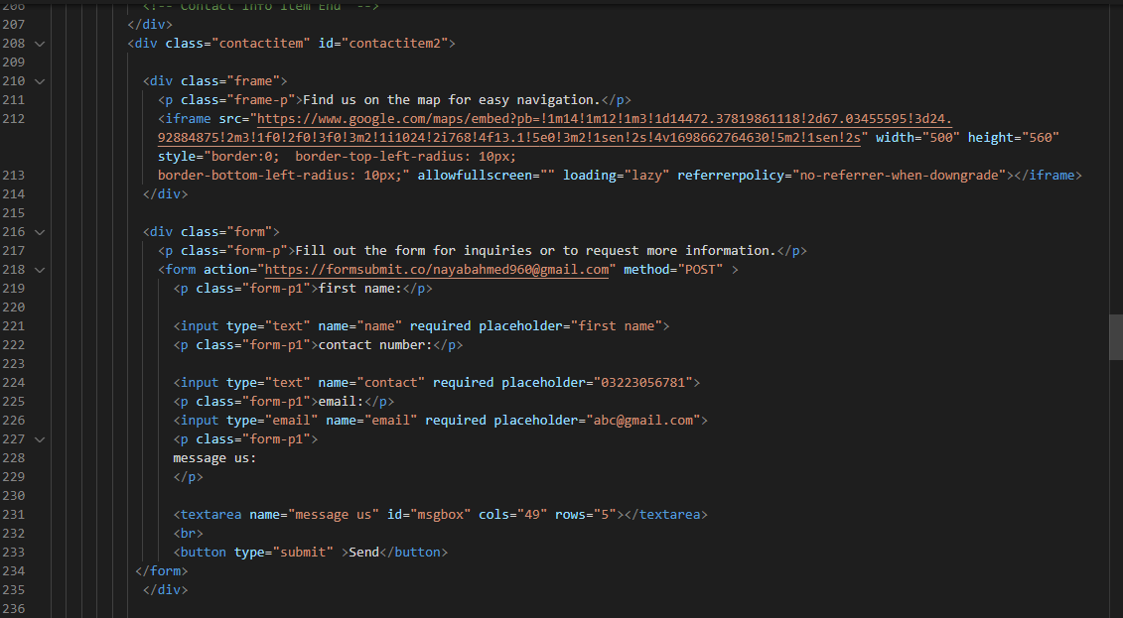

**DFD Diagram**

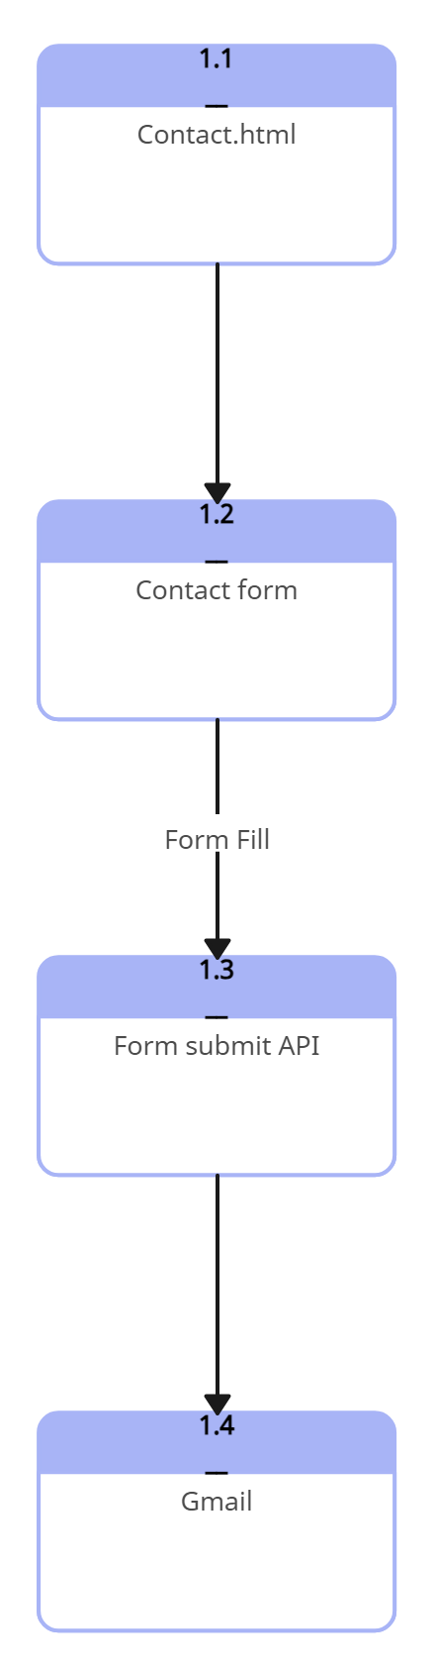

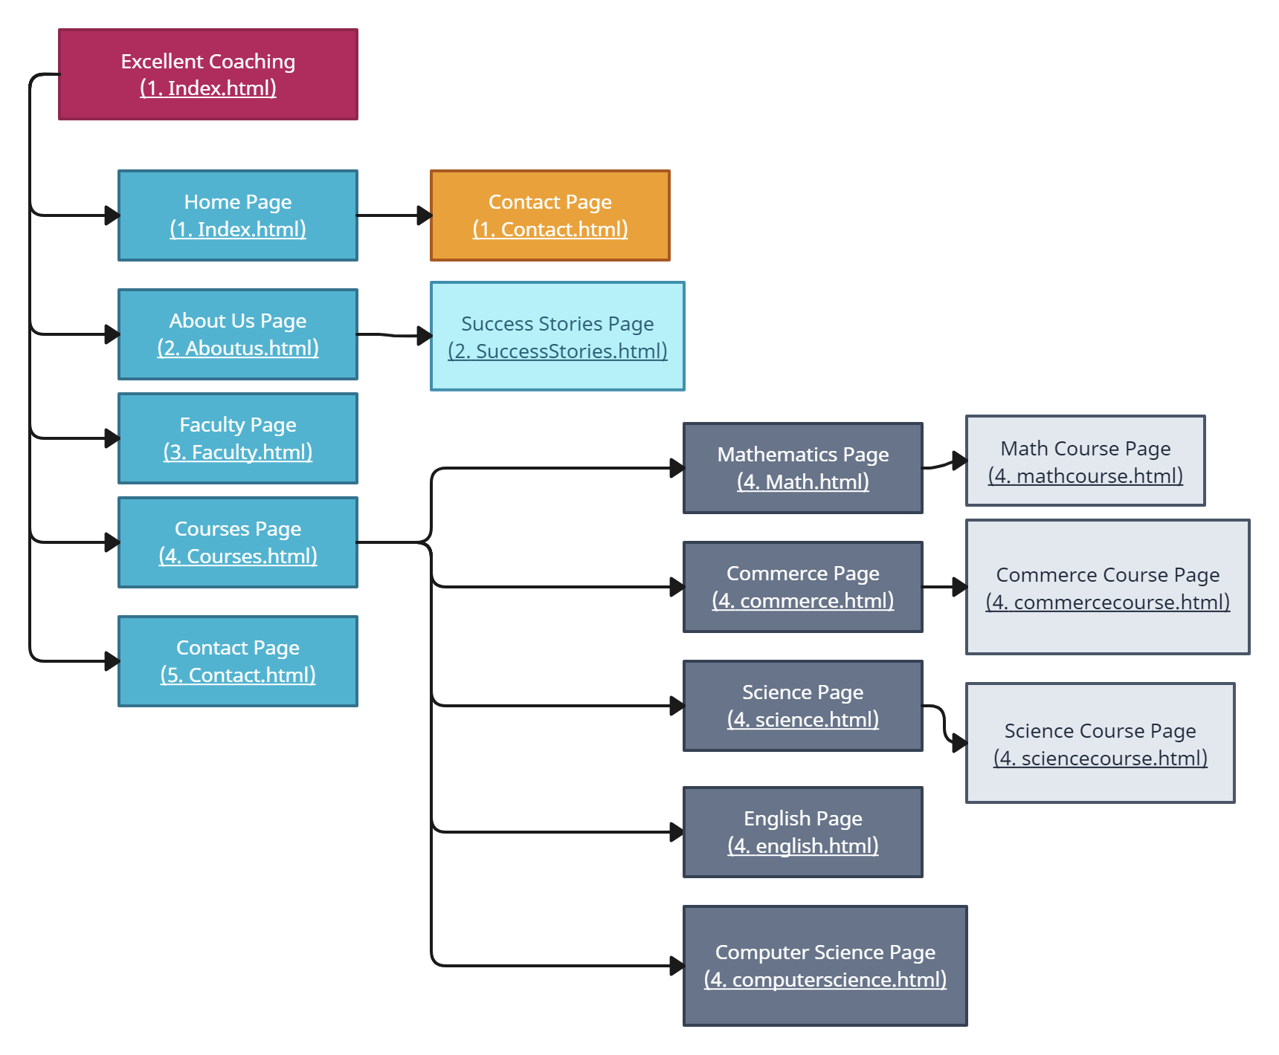**FLOWCHART**

WIREFRAME

1.Home Page (1.index.html)

HOME ABOUT FACULTY COURSES CONTACT

***EC***

BACKGROUND

Link  Link

Enroll Now

About Us

*WHY CHOOSE US:*

Read More

*Meet Our Exceptional Faculty Team*

*Image*

*WHAT SETS OUR FACULTY APART:*

*1. Expertise*

*2. Passion:*

*3. Accessibility:*

*4. Mentorship:*

*5. Innovative Teaching:*

Commerce

Science

English

Image

Image

Image

View Faculty

Mathematics

Image

View Details

View Details

View Details

View Details

*Courses*

*Testimonials*

*Slides*

*Footer*

**Get Connected with Us on Social Networks:**

###### 

###### **EXCELLENT COACHING** **EXPLORE OUR COURSES QUICK LINKS Contact**

Welcome to Excellent Coaching – Mathematics About Us 123 Example Street, City, Country

Your Path to Success! [Commerce](mailto:Commerce) Faculty info@example.com

Science FAQ + 01 234 567 88

English Contact + 01 234 567 89

###### **CONTACT**

© 2023 Copyright: [**Excellent Coaching**](http://127.0.0.1:5500/Index.html)

All rights reserved.

2.About Page (2. about.html)

**

*HOME ABOUT FACULTY COURSES CONTACT*

***EC***

*BACKGROUND*

Link  Link

*IMAGE*

*ABOUT EXCELLENT COACHING*

## *A* *DECADE OF EDUCATIONAL EXCELLENCE*

## *OUR TRANSITION TO THE DIGITAL AGE:*

### *What Sets Us Apart:*

##### *Experienced Faculty:*

##### *Comprehensive Course Offerings:*

##### *Individualized Support:*

##### *Cutting-Edge Technology:*

*OUR HERITAGE*

*OUR COMMITMENT*

*IMAGE*

### 

***Labs and creative spaces***

IMAGE

IMAGE

IMAGE

***Classroom***

***The Gym***

IMAGE

## JOIN US

*Ready to embark on your journey to a healthier, smarter, and more creative you? Explore our website to learn more about our offerings, schedules, and how you can become a part of our dynamic community. We look forward to being a part of your personal growth and well-being.*

*Our Success Stories*

IMAGE

***Computer Labs***

***Community Areas***

*Footer*

**Get Connected with Us on Social Networks:**

###### 

###### **EXCELLENT COACHING** **EXPLORE OUR COURSES QUICK LINKS Contact**

Welcome to Excellent Coaching – Mathematics About Us 123 Example Street, City, Country

Your Path to Success! [Commerce](mailto:Commerce) Faculty info@example.com

Science FAQ + 01 234 567 88

English Contact + 01 234 567 89

###### **CONTACT**

© 2023 Copyright: [**Excellent Coaching**](http://127.0.0.1:5500/Index.html)

All rights reserved.

2.About Page (2. about.html)

Success Story

**

*HOME ABOUT FACULTY COURSES CONTACT*

***EC***

*BACKGROUND*

Link  Link

|  |  |
| --- | --- |
| Image | Text |

|  |  |
| --- | --- |
| Text | Image |

|  |  |  |
| --- | --- | --- |
| Image | Text | |
| Text | | *Image* |

*Footer*

**Get Connected with Us on Social Networks:**

###### 

###### **EXCELLENT COACHING** **EXPLORE OUR COURSES QUICK LINKS Contact**

Welcome to Excellent Coaching – Mathematics About Us 123 Example Street, City, Country

Your Path to Success! [Commerce](mailto:Commerce) Faculty info@example.com

Science FAQ + 01 234 567 88

English Contact + 01 234 567 89

###### **CONTACT**

© 2023 Copyright: [**Excellent Coaching**](http://127.0.0.1:5500/Index.html)

All rights reserved.

3. Faculty Page (3. Faculty.html)

**

*HOME ABOUT FACULTY COURSES CONTACT*

***EC***

*MEET THE TEAM*

Link  Link

*Teacher Name*

*Biology*

*Teacher Name*

*English*

Co-Ordinator

Principal

Owner

*Teacher Name*

*Mathematics*

*IMAGE*

*Teacher Name*

*Business*

***MEET OUR FACULTY***

*IMAGE*

*Teacher Name*

*Biology*

*IMAGE*

*Teacher Name*

*English*

*IMAGE*

*Teacher Name*

*English*

IMAGE

IMAGE

IMAGE

IMAGE

*Teacher Name*

*Accounting*

*Teacher Name*

*Computer*

*Teacher Name*

*Chemistry*

*Teacher Name*

*Physics*

*Footer*

**Get Connected with Us on Social Networks:** 

###### 

###### **EXCELLENT COACHING** **EXPLORE OUR COURSES QUICK LINKS Contact**

Welcome to Excellent Coaching – Mathematics About Us 123 Example Street, City, Country

Your Path to Success! [Commerce](mailto:Commerce) Faculty info@example.com

Science FAQ + 01 234 567 88

English Contact + 01 234 567 89

###### **CONTACT**

© 2023 Copyright: [**Excellent Coaching**](http://127.0.0.1:5500/Index.html)

All rights reserved.

4.Courses Page (4. Courses.html)

**

*HOME ABOUT FACULTY COURSES CONTACT*

***EC***

*Background*

Link Link

***Subjects We Offer:***

|  |  |  |
| --- | --- | --- |
| *Image* | *Image* | *Image* |
| Subject 1  Button | Subject 2  Button | Subject 3  Button |
| *Image* | *Image* | *Image* |
| Subject 4  Button | Subject 5  Button | Subject 6  Button |

|  |
| --- |
| *Image* |
| Subject 7  Button |

|  |  |  |  |  |  |  |  |  |  |  |  |  |
| --- | --- | --- | --- | --- | --- | --- | --- | --- | --- | --- | --- | --- |
| ***Courses:***   |  |  |  | | --- | --- | --- | | *Image* | *Image* | *Image* | | *Course 1* | Course 2 | Course 3 | | *Image* | *Image* | *Image* | | Course 3 | Course 4 | Course 5 | |

|  |
| --- |
| ***Admission Process*** |

*Footer*

**Get Connected with Us on Social Networks:**

###### 

###### **EXCELLENT COACHING** **EXPLORE OUR COURSES QUICK LINKS Contact**

Welcome to Excellent Coaching – Mathematics About Us 123 Example Street, City, Country

Your Path to Success! [Commerce](mailto:Commerce) Faculty info@example.com

Science FAQ + 01 234 567 88

English Contact + 01 234 567 89

###### **CONTACT**

© 2023 Copyright: [**Excellent Coaching**](http://127.0.0.1:5500/Index.html)

All rights reserved.

5.Subjects / Courses

* Subjects Pages: (4. Courses.html)
* Mathematics: (Math.html)
* Commerce: (commerce.html)
* Science: (science.html)
* English: (english.html)
* Computer Science: (computerscience.html)
* Courses Pages: (4. Courses.html)
* Mathematics: (mathcourse.html)
* Commerce: (commercecourse.html)
* Science: (sciencecourse.html)

**

*HOME ABOUT FACULTY COURSES CONTACT*

***EC***

*Background*

Link Link

|  |  |
| --- | --- |
| Image | *Mathematics*  *Why Study Mathematics with Us?*   1. *Comprehensive Curriculum* 2. *Experienced Instructor* 3. *Practical Application* 4. *Intellectual Growth* |

|  |  |  |
| --- | --- | --- |
| Featured Courses | | |
| Course 1 | Course 2 | Course 3 |

|  |
| --- |
| Info |

*Footer*

**Get Connected with Us on Social Networks:**

###### 

###### **EXCELLENT COACHING** **EXPLORE OUR COURSES QUICK LINKS Contact**

Welcome to Excellent Coaching – Mathematics About Us 123 Example Street, City, Country

Your Path to Success! [Commerce](mailto:Commerce) Faculty info@example.com

Science FAQ + 01 234 567 88

English Contact + 01 234 567 89

###### **CONTACT**

© 2023 Copyright: [**Excellent Coaching**](http://127.0.0.1:5500/Index.html)

All rights reserved.

5.Contact Page (4. Contact.html)

**

*HOME ABOUT FACULTY COURSES CONTACT*

***EC***

*Background*

Link Link

|  |  |  |  |
| --- | --- | --- | --- |
| Phone | Email | Address | Office Hours |

Submit

Visit Us

First Name

Contact Number

Email

Message Us

|  |  |
| --- | --- |
| Form | Map |

*Footer*

**Get Connected with Us on Social Networks:**

###### 

###### **EXCELLENT COACHING** **EXPLORE OUR COURSES QUICK LINKS Contact**

Welcome to Excellent Coaching – Mathematics About Us 123 Example Street, City, Country

Your Path to Success! [Commerce](mailto:Commerce) Faculty info@example.com

Science FAQ + 01 234 567 88

English Contact + 01 234 567 89

###### **CONTACT**

© 2023 Copyright: [**Excellent Coaching**](http://127.0.0.1:5500/Index.html)

All rights reserved.

**TASK SHEET REVIEW**

|  |  |  |  |  |  |  |
| --- | --- | --- | --- | --- | --- | --- |
| Project Ref. No. eP/Advertisement Portal Management System/01 | | Project title | Date of Preparation of Activity Plan | | | |
| No | Task | Excellent Coaching | Actual Start Date | Actual Days | Team-mate Names | Status |
| 1 | Build Home Page | 6/10/23 | 2 | Fayez Qamar | Complete |
| 2 | Build Courses Page and Courses/ Subjects Pages | 6/10/23 | 5 | Aqsa Jamil | Complete |
| 3 | Create Price List and Subjects Info Document | 11/10/23 | 1 | Aqsa Jamil | Complete |
| 4 | Build About Us Page | 12/10/23 | 3 | Zohra &  Aqsa | Complete |
| 5 | Build Success Stories Pages | 16/10/23 | 1 | Fayez Qamar | Complete |
| 6 | Build Faculty Page | 18/10/23 | 3 | Fayez Qamar | Complete |
| 7 | Build Contact Us Page | 25/10/23 | 2 | Nayab Ahmed | Complete |
| 8 | Report User Guide | 2/11/23 | 1 | Fayez Qamar | Complete |
| 9 | Report Developer Manual | 2/11/23 | 1 | Aqsa & Nayab | Complete |